Lab –Building a Switched Network with Redundant Links

**MAC: 28:AF:FD:1A:2E:00**

**MAC: 28:AF:FD:1A:20:80**

1. Topology

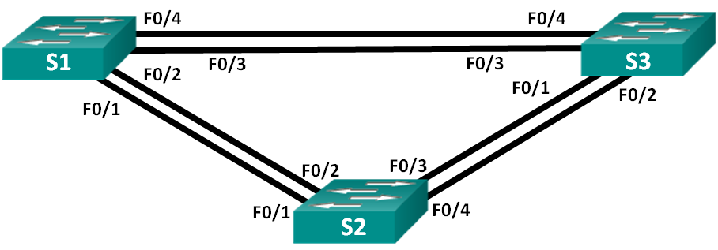

**MAC: 28:AF:1A:59:80**

1. Addressing Table

|  |  |  |  |
| --- | --- | --- | --- |
| Device | Interface | IP Address | Subnet Mask |
| S1 | VLAN 1 | 192.168.1.1 | 255.255.255.0 |
| S2 | VLAN 1 | 192.168.1.2 | 255.255.255.0 |
| S3 | VLAN 1 | 192.168.1.3 | 255.255.255.0 |

1. Objectives

Part 1: Build the Network and Configure Basic Device Settings

Part 2: Determine the Root Bridge

1. Build the Network and Configure Basic Device Settings

In Part 1, you will set up the network topology and configure basic settings on the switches.

* 1. Cable the network as shown in the topology.

Attach the devices as shown in the topology diagram, and cable as necessary.

* 1. Initialize and reload the switches if necessary. (delete vlan.dat)
  2. Configure basic settings for each switch.
     1. Change hostname as shown in the topology.
     2. Configure the IP address listed in the Addressing Table for VLAN 1 on all switches.

**int vlan 1**

**ip address 192.168.1.1 255.255.255.0**

**no shut**

* 1. Test connectivity.

Verify that the switches can ping one another.

Can S1 ping S2? Yes

Can S1 ping S3? Yes

Can S2 ping S3? Yes

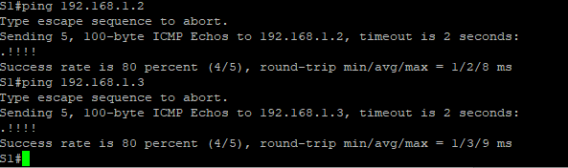

Troubleshoot until you are able to answer yes to all questions.

1. Determine the RootBridge

Every spanning-tree instance (switched LAN or broadcast domain) has a switch designated as the root bridge. The root bridge serves as a reference point for all spanning-tree calculations to determine which redundant paths to block.

An election process determines which switch becomes the root bridge. The switch with the lowest bridge identifier (BID) becomes the root bridge. The BID is made up of a bridge priority value, an extended system ID, and the MAC address of the switch. The priority value can range from 0 to 65,535, in increments of 4,096, with a default value of 32,768.

* 1. Display spanning tree information.

Issue the **show spanning-tree** command on all three switches. The Bridge ID Priority is calculated by adding the priority value and the extended system ID. The extended system ID is always the VLAN number. In the example below, all three switches have equal Bridge ID Priority values (32769 = 32768 + 1, where default priority = 32768, VLAN number = 1); therefore, the switch with the lowest MAC address becomes the root bridge (S2 in the example).

S1# **show spanning-tree**

VLAN0001

Spanning tree enabled protocol ieee

Root ID Priority 32769

Address 0cd9.96d2.4000

Cost 19

Port 2 (FastEthernet0/2)

Hello Time 2 sec Max Age 20 sec Forward Delay 15 sec

Bridge ID Priority 32769 (priority 32768 sys-id-ext 1)

Address 0cd9.96e8.8a00

Hello Time 2 sec Max Age 20 sec Forward Delay 15 sec

Aging Time 300 sec

Interface Role Sts Cost Prio.Nbr Type

------------------- ---- --- --------- -------- --------------------------------

Fa0/2 Root FWD 19 128.2 P2p

Fa0/4 Altn BLK 19 128.4 P2p

S2# **show spanning-tree**

VLAN0001

Spanning tree enabled protocol ieee

Root ID Priority 32769

Address 0cd9.96d2.4000

This bridge is the root

Hello Time 2 sec Max Age 20 sec Forward Delay 15 sec

Bridge ID Priority 32769 (priority 32768 sys-id-ext 1)

Address 0cd9.96d2.4000

Hello Time 2 sec Max Age 20 sec Forward Delay 15 sec

Aging Time 300 sec

Interface Role Sts Cost Prio.Nbr Type

------------------- ---- --- --------- -------- --------------------------------

Fa0/2 Desg FWD 19 128.2 P2p

Fa0/4 Desg FWD 19 128.4 P2p

S3# **show spanning-tree**

VLAN0001

Spanning tree enabled protocol ieee

Root ID Priority 32769

Address 0cd9.96d2.4000

Cost 19

Port 2 (FastEthernet0/2)

Hello Time 2 sec Max Age 20 sec Forward Delay 15 sec

Bridge ID Priority 32769 (priority 32768 sys-id-ext 1)

Address 0cd9.96e8.7400

Hello Time 2 sec Max Age 20 sec Forward Delay 15 sec

Aging Time 300 sec

Interface Role Sts Cost Prio.Nbr Type

------------------- ---- --- --------- -------- --------------------------------

Fa0/2 Root FWD 19 128.2 P2p

Fa0/4 Desg FWD 19 128.4 P2p

**In the diagram below, record the Role and Status of the active ports on each switch in the Topology.**

**BID**

**28af.fd1a.5980**

**BID**

**28af.fd1a.2080**

**BID**

**28af.fd1a.2e00**

**Fd1a.2080**

**S1 F0/1:**

**Desg**

**S1 F0/4: Altn**

**S1 F0/3: Root**

**S1 F0/2: Desg**

**S3 F0/1: Desg**

**S3 F0/2:**

**Desg**

**S3 F0/3: Desg**

**S2 F0/3:**

**Root**

**S2 F0/2: Altn**



**S1**



**S2**

**S3**

**S3 F0/4: Desg**

**S1 MAC: _______________________**

**S3 MAC: _______________________**

**S2 MAC: _______________________**

**S2 F0/1:**

**Altn**

**S2 F0/4:**

**Altn**

Based on the output from your switches, answer the following questions.

Which switch is the root bridge? 3

Why did spanning tree select this switch as the root bridge?

The BID is the lowest compared to the others

Which ports are the root ports on the switches? S1 F0/3, S2 F0/3

1. Change Root Bridge

An election process determines which switch becomes the root bridge. The switch with the lowest bridge identifier (BID) becomes the root bridge. The BID is made up of a bridge priority value, an extended system ID, and the MAC address of the switch. The priority value can range from 0 to 65,535, in increments of 4,096, with a default value of 32,768.

Change the Root bridge to S3 (Note: if its already S3 change to S1)

S3(config)# **spanning-tree vlan 1 root primary**

What is the Priority Value of the new Root Brigde? 20481

1. Per Vlan STP

Create VLAN 10 and VLAN 20 on all switches.

**vlan 10**

**vlan 20**

Make all the links between the switches trunks.

**int range fa0/1-4**

**switchport mode trunk**

Run the **show spanning-tree** command

How many instances of STP are running? 3

Change the Root bridge to S1 for Vlan 10

S1(config)# **spanning-tree vlan 10 root primary**

Change the Root bridge to S3 for Vlan 20

S3(config)# **spanning-tree vlan 20 root primary**

Run the **show spanning-tree** command

Which Ports on which Switch are Blocked (Altn) for Vlan 10 ? S2 Fa0/2-4

Which Ports on which Switch are Blocked (Altn) for Vlan 20 ? S3 Fa0/4, S1 Fa0/2-4